MADHAV INSTITUTE OF TECHNOLOGY AND SCIENCE, GWALIOR

SUBMITTED BY-

ASMITA JAIN

0901EO201017

SUBMITTED TO-

PROF. APRAJITA KUMARI

**SENSOR TECHNOLOGY LAB 220202**

**EXPERIMENT - 4**

**AIM:**

To draw the characteristic of strain gauge sensor.

**THEORY:**Strain: The deformation in a material due to applied force, i.e. the change is known as strain gauge.

Strain Gauge: It is a resistor used to measure strain. The change in length due to applied force in a material affects the resistance of it. This strain gauge is connected to the Wheatstone bridge, when resistance changes , deflection occurs in the gauge.

Resistance variation in strain gauge is exactly proportional to the strain.

Tension cause increase in resistance and compression causes decrease in resistance.

Strain gauge factor = per unit change in resistance

per unit change in length

=(ΔR/R)/Strain

Output voltage for –

1. Quarter bridge = ( ¼) (ΔR/R) x E
2. Half bridge = (1/2) (ΔR/R) x E
3. Full bridge = (ΔR/R) x E

Where,

E= applied voltage

R= Resistance

ΔR = Change in resistance

**CIRCUIT DIAGRAM:**

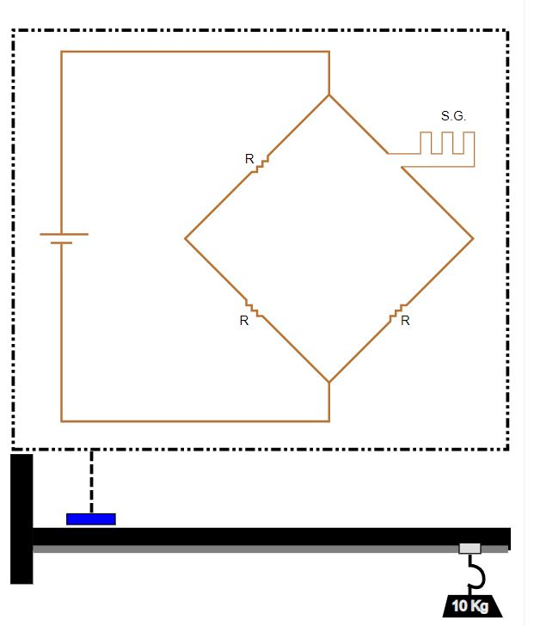

**OBERSERVATION TABLE:**

Configurations-

* E= 5V
* R= 120
* Gauge factor = 0.9
* Material = copper
* Configuration = quarter

|  |  |  |
| --- | --- | --- |
| Weight (in Kg) | Change in R | e (in mV) |
| 0.5 | 0.0136 | 0.14 |
| 1 | 0.0271 | 0.28 |
| 2 | 0.0542 | 0.56 |

**GRAPH:**

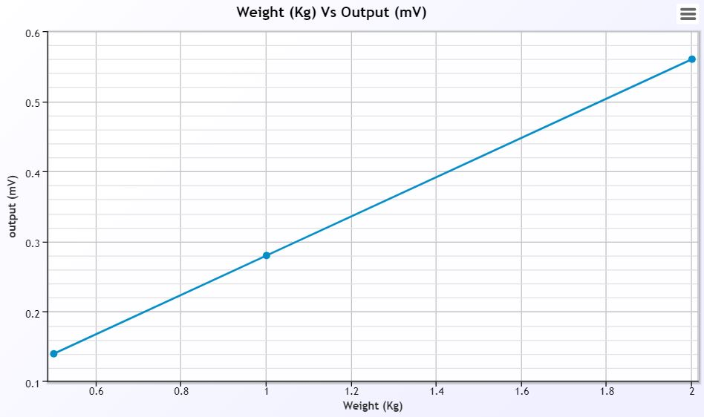

**RESULT:**

Hence, verified the strain gauge sensor characteristic.